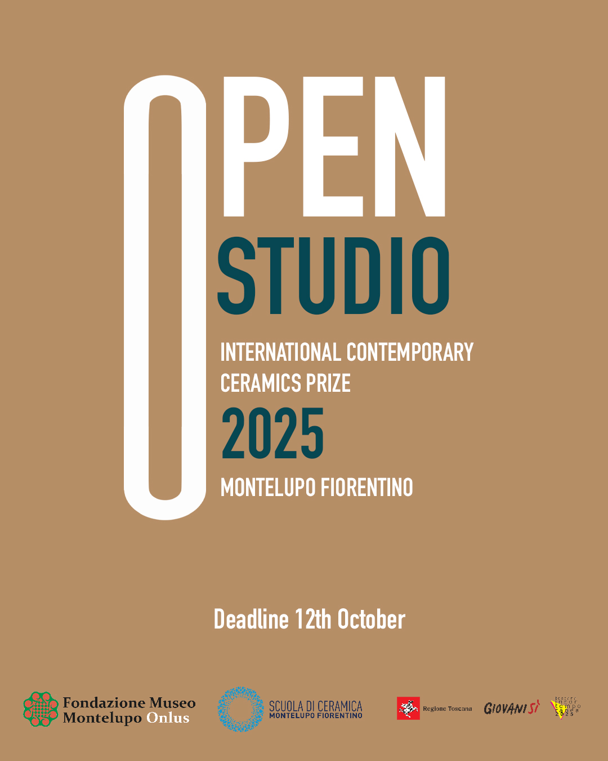
Attachment A – PARTICIPATION FORM
For groups, this form must be completed and signed by each participant

OPEN STUDIO
International Contemporary Ceramics Prize
Montelupo Fiorentino

To be completed in full and sent by 12 OCTOBER 2025 to the following address:
openstudio@museomontelupo.it

The undersigned:

PERSONAL DETAILS OF THE PARTICIPANT (for individual participation or as lead artist of a team):

- Full Name:
- Date of Birth:
- Nationality:
- Full Address:
- Phone / Mobile:
- Email:

Applying as: (please check the appropriate box)
INDIVIDUAL PARTICIPANT
LEAD ARTIST OF THE FOLLOWING ARTIST TEAM

(The following sections must be filled in only in the case of group participation, with the details of all additional members):

TEAM PARTICIPANT
- Full Name:
- Date of Birth:
- Nationality:
- Full Address:
- Phone / Mobile:
- Email:

TEAM PARTICIPANT
- Full Name:
- Date of Birth:
- Nationality:
- Full Address:
- Phone / Mobile:
- Email:

TEAM PARTICIPANT
- Full Name:
- Date of Birth:
- Nationality:
- Full Address:
- Phone / Mobile:
- Email:

TEAM PARTICIPANT
- Full Name:
- Date of Birth:
- Nationality:
- Full Address:
- Phone / Mobile:
- Email:

REQUESTS

TO PARTICIPATE IN THE INTERNATIONAL CONTEMPORARY CERAMICS PRIZE
OPEN STUDIO WITH THE FOLLOWING WORK:

TITLE:
YEAR:
TECNIQUE AND USED MATERIALS:
DIMENSIONS (HEIGHT X WIDTH X DEPTH IN CM):

Concept of the work
(this text will be used by the Organizer for publication if selected among the finalists – max 300 characters including spaces):

Updated biography of the artist or the team:
(this text will be used by the Organizer for publication if selected among the finalists – max 750 characters including spaces; include links to relevant web pages if applicable):

DECLARES

That the submitted work is their own property, was created within the last two years, and that the application does not infringe upon the rights of any third party.
That the work:
has been previously presented
or
has not been previously presented
in other competitions or exhibitions.
(If the work is not new, please specify the relevant competition(s) or exhibition(s))

ATTACH THE FOLLOWING MATERIALS
(in a single email or compressed folder)

High-resolution images (max 3, JPG or PNG)
Copy of a valid ID document (JPG, PNG or PDF)
Privacy Policy and Release Form for the use of images, videos and personal data

Participation in the Open Studio Prize implies full knowledge and acceptance of the regulations and all related attachment.

Place and Date

_________________________

Signature (For group submissions, the signature of each team member is required)

_________________________

PRIVACY POLICY AND RELEASE FORM
(To be completed and signed by each participant and submitted as a single PDF in case of collective participation)

Personal Data Processing
In order to participate in this call for entries, applicants are required to provide personal data and information, including in documentary form, which fall within the scope of the General Data Protection Regulation (GDPR) 2016/679 and relevant national legislation on privacy.
Pursuant to the aforementioned legislation, the Foundation is required to provide information regarding the use of such data.
The data will be collected for the purpose of participation in the call, particularly to carry out verifications and to enable the awarding of prizes, and in compliance with current legal requirements.
Data processing will be carried out in a manner that ensures security and confidentiality, and may involve electronic and digital tools suitable for storing, managing, and transmitting said data. These data may also be combined with those of other individuals based on qualitative, quantitative, and time-related criteria determined on a case-by-case basis.
Some of the data submitted with the application may be disclosed to third parties external to the Foundation and/or published, in accordance with and respecting the relevant legislation.
Concerning the above data, participants, as data subjects, are entitled to exercise the rights laid out in Articles 15–21 of GDPR 2016/679.
The submission of the application implies acknowledgment of this privacy notice and the modalities for personal data processing described herein.
The data controller is Fondazione Museo Montelupo Onlus.
The artist agrees to the use of photo and video material produced during the project and to the publication of such materials on the communication channels of the project and in the press, by the Foundation, its project partners, and designated collaborators.

The Artist (Name and Surname):

Place and Date

_________________________

Signature

_________________________

